WEEK 11 ANCOVA AND ANOVA
Notes by Elizabeth Braatz, using websites cited below and Chat GPT
Definitions

https://testbook.com/key-differences/difference-between-anova-and-ancova

ANOVA (Analysis of Variance) is a statistical technique used to test the equality of means across multiple groups or levels. It is used to determine whether there are significant differences between the means of two or more groups.
ANCOVA (Analysis of Covariance) is a statistical technique that is used to analyze the relationship between a dependent variable and one or more independent variables while adjusting for the effects of one or more covariates. It can be thought of as a combination of ANOVA and regression analysis, as it allows you to test for differences in means while controlling for the effects of other variables.

 | ANOVA | ANCOVA
Purpose | Compare means of two or more groups | Compare means of two or more groups while controlling for the effects of one or more covariates.
Assumptions | Normality and equality of variances | Normality, equality of variances, and linearity between the dependent and independent variables are assumed.
Test statistic | F-value is used as test statistic | F-value or partial F-value are used as test statistic
Null hypothesis | The means of all groups are equal | The means of all groups are equal after adjusting for the effects of the covariates
Alternative hypothesis | Means of at least one group is different | Means of at least one group is different after adjusting for the effects of the covariates
Post-hoc tests | Tukey's HSD, Scheffé's test, etc. can be used for post-hoc analysis | Tukey's HSD, Scheffé's test, etc., or tests specific to the covariates used can be used for post-hoc analysis.

More Definitions

https://statisticseasily.com/ancova-versus-anova/

Highlights
- ANOVA assesses the impact of one or more independent categorical variables on a single, continuous dependent variable.
- ANCOVA is a generalized form of ANOVA, introducing covariates to adjust the model.
- The main difference is ANCOVA’s ability to control for the effects of certain variables, which ANOVA doesn’t.
- ANOVA is simple and widely applicable but can’t account for confounding variables.
- ANCOVA adjusts for covariates, providing a more nuanced understanding of variables’ interactions.
Examples
ANOVA: A Practical Example
A botanist wants to test whether three fertilizers lead to different plant growth rates. The botanist grows three batches of plants. Batch A is fertilizer 1, batch B is fertilizer 2, and batch C is fertilizer 3. After several weeks, the botanist measures the growth of the plants in centimeters.
In this case, the botanist could use ANOVA to determine whether growth rates are statistically different between the three batches. The dependent variable is the plant growth rate, while the independent variable is the type of fertilizer used.
ANCOVA: A Practical Example
Now let’s add a twist to our previous scenario. Besides considering the different fertilizers, the botanist also notices that the amount of sunlight each batch receives may affect the plants’ growth. However, sunlight isn’t the main focus of the experiment.
In this case, ANCOVA would be the appropriate method to use. The botanist can treat the amount of sunlight each batch receives as a covariate. This way, the botanist can still investigate the effect of different fertilizers (the primary independent variable) on plant growth (the dependent variable) while controlling for the amount of sunlight (the covariate).
Thus, with ANCOVA, the botanist can evaluate whether different fertilizers have a different effect on plant growth after adjusting for the amount of sunlight each batch receives. This will give a more precise understanding of the fertilizers’ impact, as it removes the variation in growth caused by differences in sunlight exposure.
By using these statistical methods appropriately, the botanist can gain accurate insights into the effects of different fertilizers on plant growth, improving their future experiments and contributing to their field’s understanding.

Pitfalls
Does order matter when fitting
Fit = lm(y variable ~ covariate + group)
Not when JUST running a lm
- We’re not asking for an anova (sum of squares partition)
- We are asking for a regression summary (coefficient estimates, t-tests, R2, etc.)
- The cake is baked once by lm() (thank you Chat GPT)
- But how we slice it (Type I, II, III) depends on what knife you use, ie which function you call to summarize it
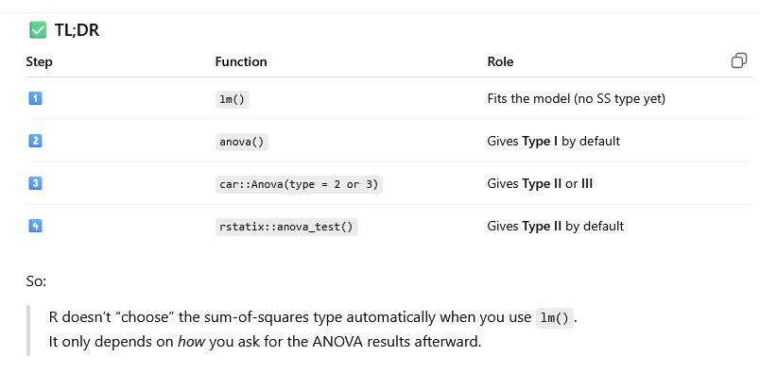
So what do we mean by Type I, II, and III ANOVA?
- In ANOVA, we are partitioning hte variability of hte dependent variable into parts explained by different predictors nad their interactions
- Each predictor gets a ‘sum of squares’ SS
  - SS = how muh variance does this factor explain?
- But when you have multiple predictors, their effects can overlap
- So we have to decide who gets what part of hte pie

Type I - Sequential SS
- Tests each term in the order that it appears in the model
  - First variable (pretest) is tested alone
  - Second variable (group) is tested after adjusting for pretest
- When to use Type I
  - When predictors are orthogonal (completely independent)
  - Don’t use when predictors are correlated, like in ANCOVA, order then changes the meaning

Type II - Hierarchical SS
- Tests each main effect after adjusting for all other main effects, but ignores interactions
- So
  - Group is tested after controlling for pretest
  - Pretest is tested after controlling for group
- When to use Type II
  - You have no significant interaction or didn’t include one
  - You want to know each main effet’s unique contribution regardless of order
  - Typically preferred for ANOVA because it gives you the effect of the group, after accounting for the pretest, regardless of order

Type III - Marginal SS
- Tests each term after controlling for all other terms, including interactions
- So
  - Group is tested after adjusting for both pretest and the group:pretest interaction
  - Works even if the design is unbalanced
- When to use Type III
  - You have interactions in the model
  - Your data is unbalanced (unequal group sizes)
- Warning
  - You need to really carefully adjust it with contrast coding (contr.sum, contr.helmert) for it to spit out the right results

LOL Chat GPT AI’s attempt at providing a ‘helpful’ diagram describing the difference between anova and ancova

